Readiness Checklist for GenAI Agentic RAG Hackathon.

Step1- Login to Google Colab- <https://colab.research.google.com/>

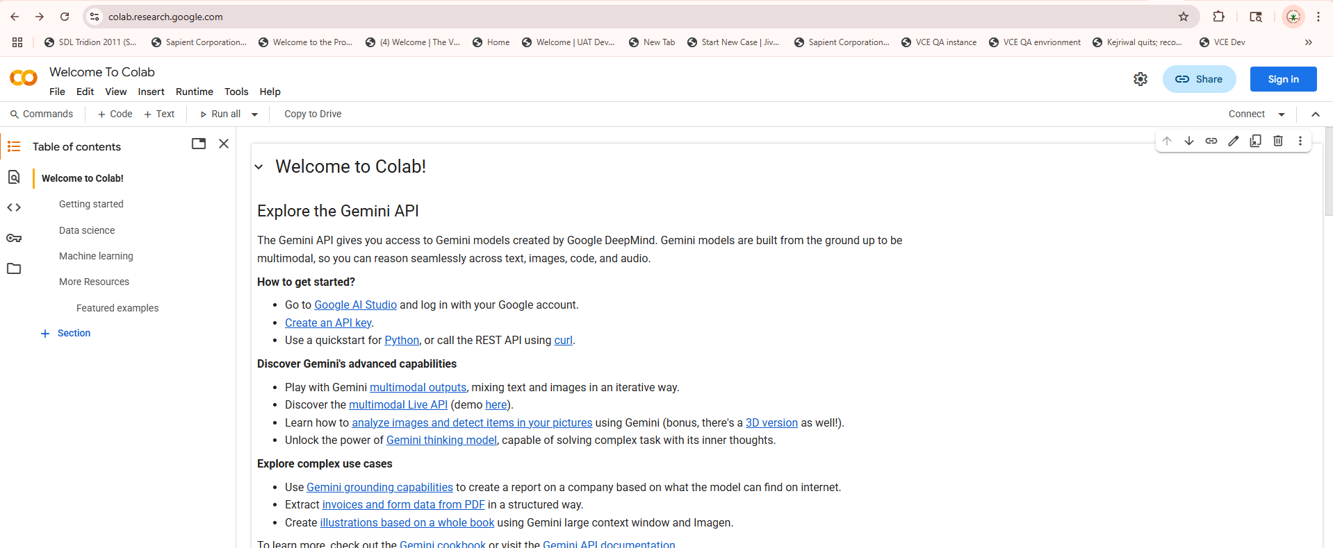

Step2: Sign in with you gmail id click on new notebook

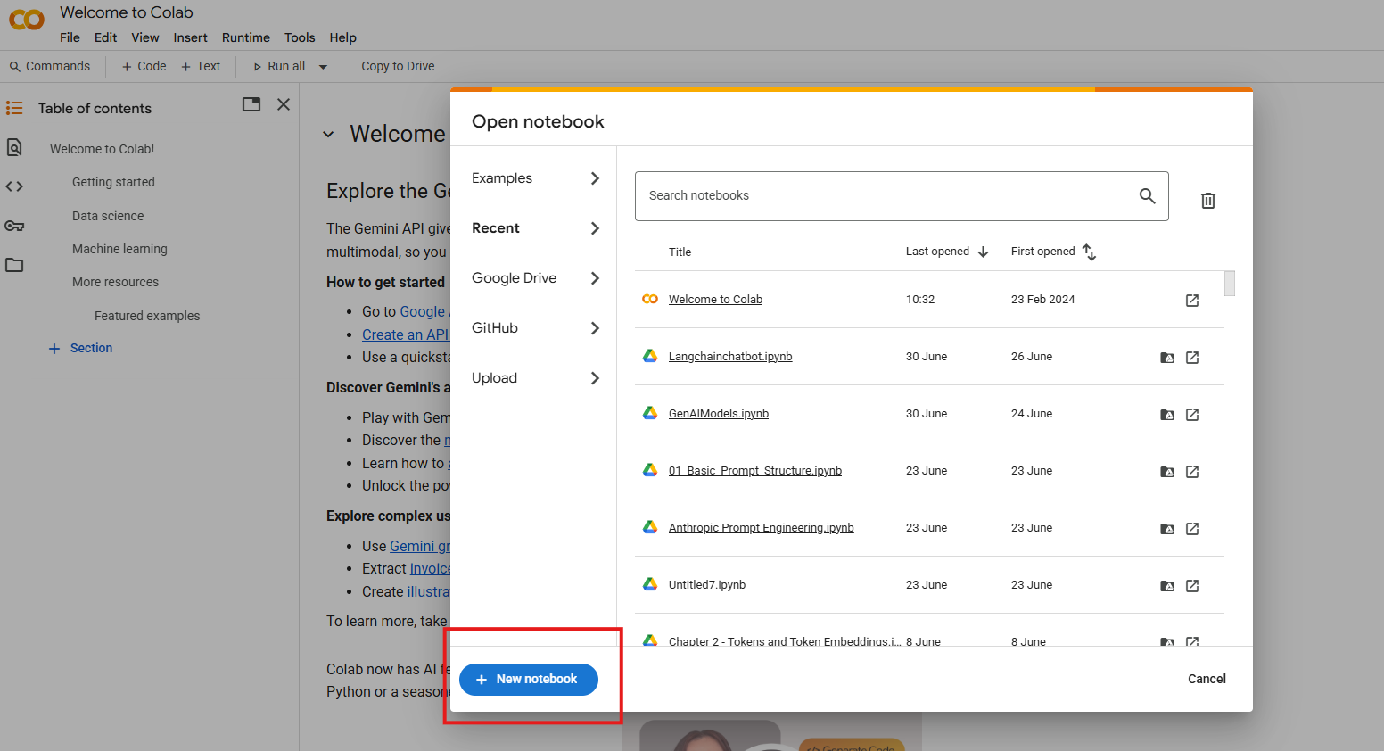

Step3: A new colab notebook would open. Rename it as “GenAI Agentic RAG Chatbot”

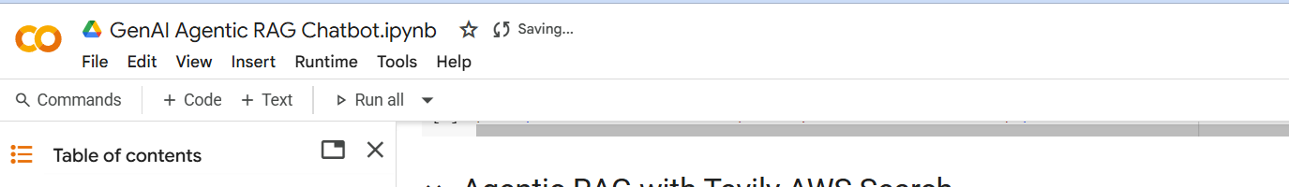

Step4: Get the OpenAI API Key:

Login to <https://platform.openai.com/api-keys>

Click on create API Key

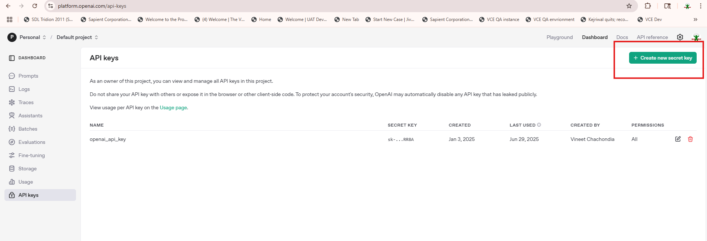

**Copy and Save your OpenAI Key in your system for future reference.**

Step5: Get .Tavily API Key

Login to[**https://app.tavily.com/home**](https://app.tavily.com/home) **using your gmail**

Click on create API Key

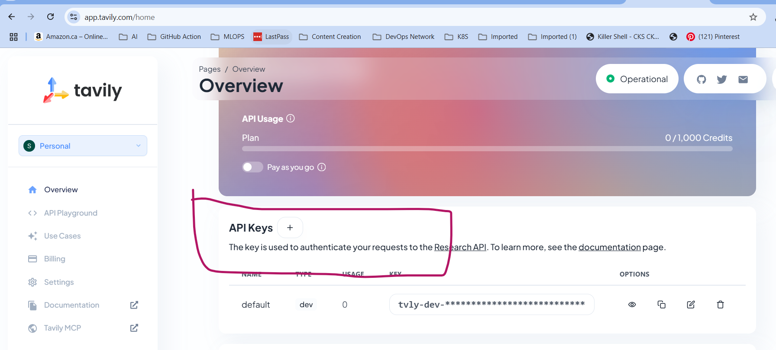

**Copy and Save Groq API key in your system for future reference**

Step6: Update your colab secrets with API Keys

Go to Colab Notebook and click on secrets key(a key symbol) on the left hand side menu

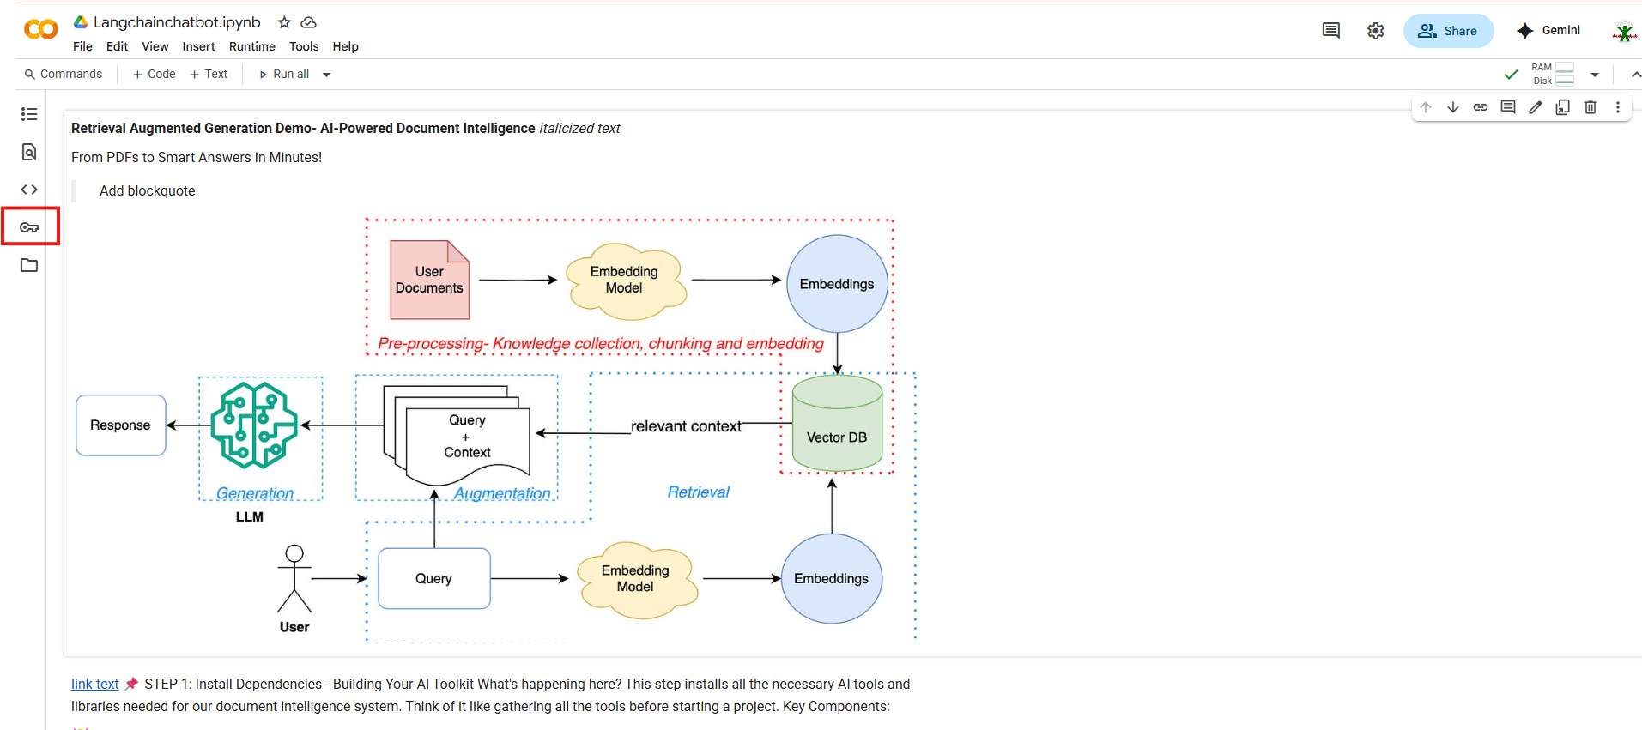

Click on add new secrets

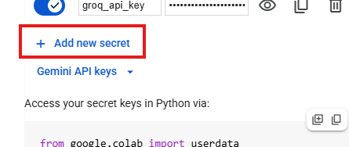

In the name text box put “ OPEN_API_KEY” and “TRAVILY_API_KEY”(all in caps). In the value put your api key which you have created and save earlier. Enable the notebook access.

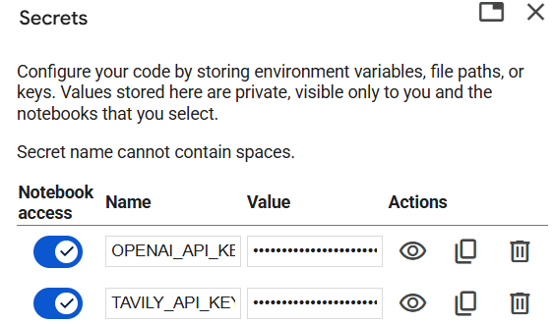

**Awesome, you are all set to use your colab notebook for the hackathon.**

Step7: Download the code file(**RAG Hackathon Langchainchatbot.ipynb**) from this github repo link:

https://github.com/sbaghwala/gentic_rag/blob/main/python_code/GenAI_Agentic_RAG_Chatbot.ipynb

Click on download button on the top right

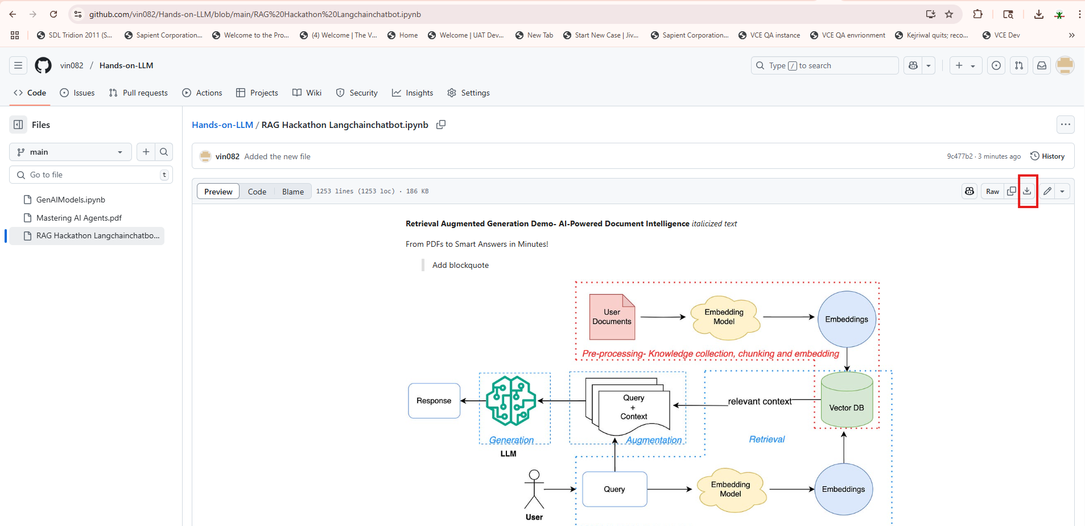

Step8: Upload the downloaded ipynb file in your colab notebook.

Click on File Menu- Upload notebook

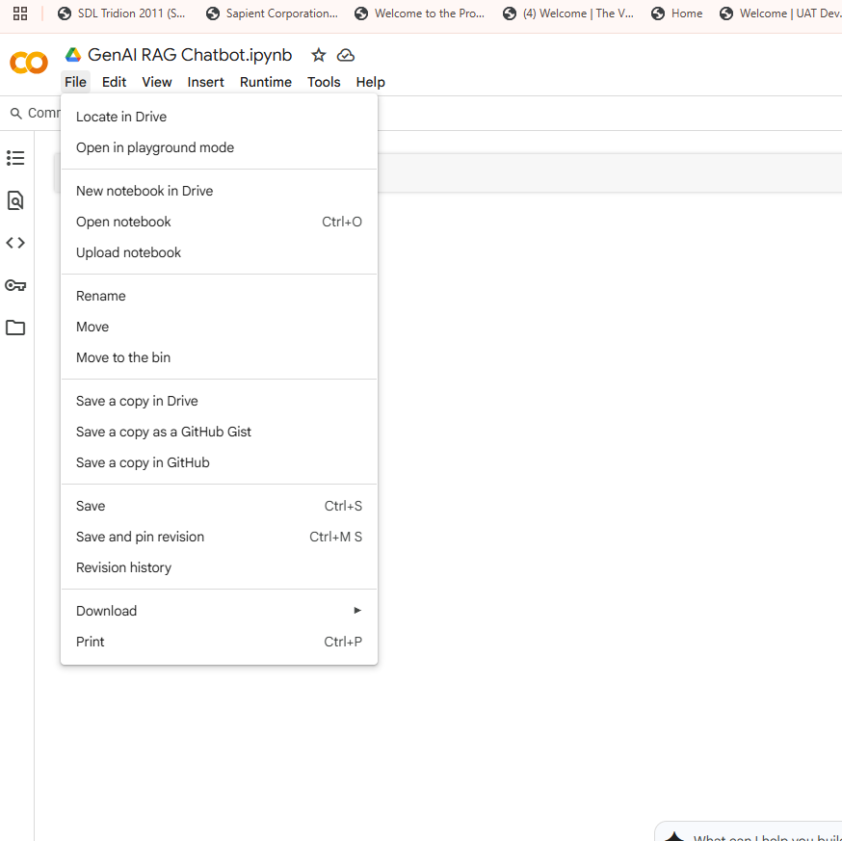

Browse and upload the **RAG Hackathon Langchainchatbot.ipynb** file form your system downloaded from github repo.

You can use the Sample Q&A at <https://github.com/sbaghwala/gentic_rag/blob/main/python_code/Q%26A.md> by putting the question as below   
 ask_migration('How does our ACCVAL01 program handle overdraft calculations?')

You are all set for the Hackathon. Good luck!!